Cons of Paper Recycling
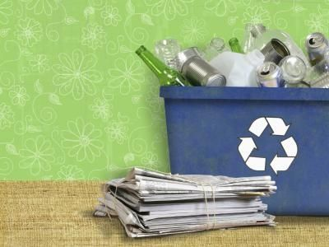
By Dan Taylor, eHow Contributor

Americans recycled 88 percent of newspapers in 2006, higher than any other paper product, according to the Environmental Protection Agency.
As the world looks for ways to improve the environment, recycling items such as paper is a popular option for localities trying to push green energy initiatives. But while there are some undisputed advantages to recycling paper products instead of just throwing them away, critics point to a number of drawbacks in the practice.

- High Cost
  - The cost of collecting recycled paper often exceeds how much the local government can get for the finished product on the open market. Localities must also operate additional trucks to pick up the recyclable paper, burning fuel and offsetting environmental gains. It is often much cheaper for governments to simply dump the paper in a landfill, according to Environmental Health Perspectives. Also, ReUseIt notes that it takes 91 percent less energy to recycle a pound of plastic than to recycle a pound of paper.

Benefits Difficult to Quantify
  - Health and environmental benefits of recycling paper are usually indirect and difficult to quantify, EHP notes.

